GeTS project: Geo2Tag usage in e-Tourism

Line 1 - FullName1, FullName2
Line 2 - Name of organization1
Line 3 - City1, Country1
Line 4 - Author1, Author2@domain.edu
FullName3
Name of organization2
City2, Country2
Author3@domain.edu

Abstract—The abstract describes a summary of the paper. In some cases, the authors confuse the abstract with the introduction. In the abstract using of acronyms and abbreviations is undesirable.

Introduction
- The role of tourism
- The role of e-Tourism
- Different objects for usage
- Common service for various cases
- usage of geo2tag lbs platform
- main goal: create middleware service based on geo2tag
II. Typical use cases
In this section we are describes a typical use cases which are founded in most applications for tourists. These use cases combined into three parts: operations with points, tracks and polygons. The GeTS project development based on these use cases.
A. Operations with points
In this use case application got amount of points from some service and present it to the user. Commonly, application supports restricted types of objects. For example application WorldAroundMe [worldaroundme] works only with images. Thereby an application requires an amount of points, divided by categories. Some applications supports to add new points by the user. In this case point provided with coordinates, type and data (text, image or link to image, etc.).
This use case is more convenient for using in geo2tag architecture. All points are presented by a tags and groups into channels. Both other use cases uses points as a structural element and therefore any point in geo2tag database can be used in this use case.
B. Operations with tracks
In this use case application uses a sequence of points to present a track. Commonly, application uses roads for presenting track arcs. Based on main target, application uses various objects with the track. For example, track presents as a travel log in application TourMe [tourme] and track presents as a audio guide in AudioGuide application [audioguide]. Thereby the data object must be recognized as a track and associated with the category. In worst case each point in the track must be associated with the category.
The track is convenient for using in geo2tag architecture if service works only with tracks. Each channel presents as a track and tags in channel presents as a sequence of track points. If geo2tag contains tracks and other objects then the channels with track must be marked in a special way and recognized by applications.
C. Operations with polygons
In this case application got information about some areas and presents it to the user. For example, in Hunter handbook application [hunter handbook] areas used for presenting reserves and hunting ground. This use case is similar to th operations with tracks except that the points are equivalent.
The polygons are also convenient for using in geo2tag architecture if service works only with it. Each channel presents as a polygon, tags in channel presents as a sequence of polygon points and first and last points are linked. If geo2tag contains polygons and other objects then the channels with polygons must be marked in a special way and recognized by applications.
III. Geo2Tag platform analysis
The Geo2Tag LBS platform provides the following functionality throw application programming interface (API) [geo2tag funcs]. Application or service sends to Geo2Tag query in JSON format [json] and receives answer with data or error code in JSON format.
1) Registration and authorization. Geo2Tag has own user database. In earlier versions application can register user by sending request, but now geo2tag used special web form. User should have unique name and e-mail address. There are no methods to change password or delete user except for direct access to database. After authorization geo2tag receives unique string – token. The token uses in other requests to geo2tag service.
2) Work with channels. Geo2Tag API supports channel creation and subscription. The Geo2Tag client can see all channels and subscribed channels. Geo2Tag supports only channel unsubscription without deletion. The channel presents as a object with name, description and URL. The channel name should be unique for whole Geo2Tag database.
3) Work with tags. Geo2Tag API supports adding tags to the end of tag list in channel and loading tags by using set of “2D” and “3D” requests and filters. There are no functions to insert tag into the certain position, update tag data or remove tag from channel. The requests and filters works only for subscribed channels. If client subscribe channel, then it can add tags to this channel.
In total geo2tag has simplified functionality for work with users, doesn't classified channels and tags and doesn't provide destructive functionality.
IV. GeTS project architecture
The high-level architecture of GeTS project is presented in Fig. 1. GeTS project consists of two parts: GeTS scripts and GeTS service. Also GeTS project contains Geo2Tag database improvements (see section V).
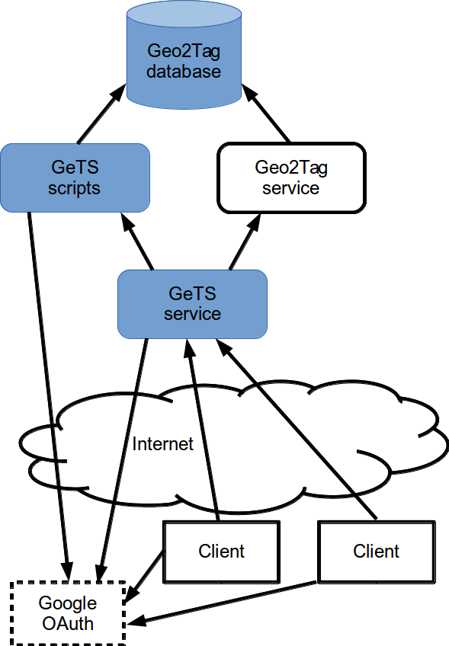
Fig. 2. Red, blue and green line
GeTS scripts used for implementation Geo2Tag missing functionality and to access to additional database objects. It's organized as a independent service with direct access to the Geo2Tag database. The GeTS scripts API based on XML-RPC protocol.
GeTS service implements XML-based API for clients and uses GeTS scripts and Geo2Tag to load and store data. GeTS service uses Geo2Tag token and session mechanism to provide simultaneous access from multiple clients.
GeTS project uses Google OAuth service [google] for client authentication. Google OAuth service uses two-step authentication process: First, client send to Google OAuth service request to access and approve it. After that client send to GeTS server Google authorization code. Second, GeTS server sends to Google OAuth service authorization code and receives Google token. Combined with GeTS project, we have three-step authentication: the last step is to get Geo2Tag token based on Google OAuth token.
V. Data objects
A. Points, tracks and polygons
Geo2Tag channels and tags uses for storing points, tracks and polygons. Attractions stores in in channels grouped by category. Each track and polygon stores into separate channel.
The channel name value includes prefix for object type identification (“ca_” for points, “tr_” for tracks and “pl_” for polygons), owner name and additional string (e.g. category short name for points). It's provide unique channel name in Geo2Tag database. Also it's provides fast points selection in queries, because Geo2Tag returns tag properties and corresponded channel name.
The channel description field stores data in JSON format and contains the following properties:
- description text. This text uses to show object short description;
- category ID. All points in this channel corresponds to this property.
- language ID. This property uses to filter channels for client or to use automatic translation of channel and tag text data to requested language.
For tracks and polygons channel data considered as object data, but for points also these properties can be set in tag description field.
Each object can be presented in the multiple categories. In this case point data copied into channels corresponded to selected category, tracks and polygons presented in separated channel.
B. Categories
Categories presents in additional table of Geo2Tag database. Category object contains typical properties for Geo2Tag: category ID, name, short description and URL. GeTS adds support of complex categories: the category name can be divided to the sequence by dot. The processing of complex categories (organization as a tree, subcategory selection, etc.) should be in client side.
Also for support multiple GeTS servers in single Geo2Tag service category includes main administrator name property for access restriction organization.
C. Localization
Most text data in GeTS database can be presented in various languages automatically using external services. For example, wikipedia [wikipedia] has various links to articles for single object like city. The one way is to store objects into different channels corresponds supported language, but it requires strong synchronization process. The another way is to present localization data in additional table of Geo2Tag database. This table contains object properties (name, type) and corresponded localized values (name, description, URL).
D. Users
Geo2Tag presents user as a set of properties: name, e-mail and password. Also Geo2Tag requires unique name and e-mail for all users. With accordance of using Google OAuth service GeTS service at new user registration fill all fields by e-mail value which are provides by Google OAuth service.
The one user identified as a main administrator. It required for using multiple GeTS servers with single Geo2Tag service.
Also GeTS provides two categories of users: trusted user and administrator. Trusted user is able to provide on content to other users. Administrator can manage service data. Both user categories presented as a additional tables in Goe2Tag database and each record contains two values: user name and main administrator name.
VII. Conclusion
I hope this article will help you to create a new article. In the end I would like to ask you, if you send your source files personally to editor, name it in accordance with the number in the system or the name of the first author.
FRUCT template developed on the basis of IEEE templates.
Acknowledgment
We would like to thank authors considerate to their articles design and reviews. Popular drawbacks for submissions of FRUCT13 are shown in the Table I. An excellent style manual for science writers is [10].

TABLE I. Popular drawbacks for submissions of FRUCT13
Drawbacks in | Number of submissions
Paper Title | 7
Information about authors | 2
Index Terms | 11
Title of sections | 9
General text | 10
Figures and tables | 15
Lists | 4
References | 13
Design do not match our template | 7
In total number of submissions | 40

References
- (Example for books) T.M.Cover and J.A. Thomas, Elements of Information Theory. New York: Wiley, 1991.
- (Example for articles) R.L. Dobrushin, “Optimum information transmission through a channel with unknown parameters”, Radiotech.Electron., vol.4, Dec.1959, pp. 1951-1956.
- (Example for articles) N.M. Blachman, “Communication as a game”, in Proc. WESCON Conf., Aug. 1957, pp. 61-66.
- (Example for web-links) IEEE official website, Manuscript Templates for Conference Proceedings, Web: http://www.ieee.org/conferences events/conferences/publishing/templates.html.
- (Example for unpublished references) K. Elissa, “Title of paper if known”, unpublished.
- (Example for references have been accepted for publication) R. Nicole, “Title of paper with only first word capitalized”, J. Name Stand. Abbrev., in press.
- M. Young, The Technical Writer’s Handbook. Mill Valley, CA: University Science, 1989.
- (For number of references) G. Eason, B. Noble, and I.N. Sneddon, “On certain integrals of Lipschitz-Hankel type involving products of Bessel functions”, Phil. Trans. Roy. Soc. London, vol. A247, pp. 529-551.
- (For number of references) C. E. Shannon, “A mathematical theory of communication”, Bell Syst. Tech. J., vol. 27, 1948, pp. 379-423.
- (For number of references) D.S. Johnson, “The NP-completeness column: an ongoing guide”, Journal of Algorithms, 9 (1988), 426-444.
- (For number of references) J. Clerk Maxwell, A Treatise on Electricity and Magnetism. Oxford: Clarendon, 1892, pp.68-73.

